  - Inpatient - Cosign Guide
Intended Audience: Nursing Instructors, Nurses, Inpatient Therapy, Respiratory Therapists, Nutrition, Child life, and Music Therapy who are supervising Students, Interns, Externs, or Graduate Professionals.
Summary: In Epic there is additional functionality for people learning the profession to document assessments, notes, patient care documentation, and medication administrations as applicable. These are referred to in this guide as “Students” but may be a variety of roles such as: Intern, Extern, Graduate Nurse or Student.
Students need to be cosigned by a licensed professional because the student does not have the authority to sign the documentation independently. By performing the act of cosigning the documentation, the licensed professional is validating that the documentation entry has been reviewed, is believed to be accurate, complete, and appropriately reflects the care provided/described.
NOTE: Cosigning student documentation is done by the faculty responsible for the student when possible. The preceptor will cosign when faculty is not present.

Contents
Student: 2
Selecting a Cosigner 2
Medication Administration (Nursing and Respiratory only) 2
Writing Notes (Allied Health Only) 2
Staff: 3
Cosign from Reports 3
Cosign from Flowsheets 3
Cosign from Notes (Allied Health Only) 4
Cosign from Navigators (Allied Health Only) 4
Add a Patient List Column 4

Student:

Selecting a Cosigner
When the student logs into Epic the student will choose the appropriate licensed professional in charge of cosigning their documentation.
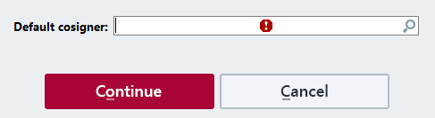

Medication Administration (Nursing and Respiratory only)
When giving a medication a different cosigner can be selected when scanning the medication. When the administration window pops up, a different name can be searched and entered in the Request Cosign by field.
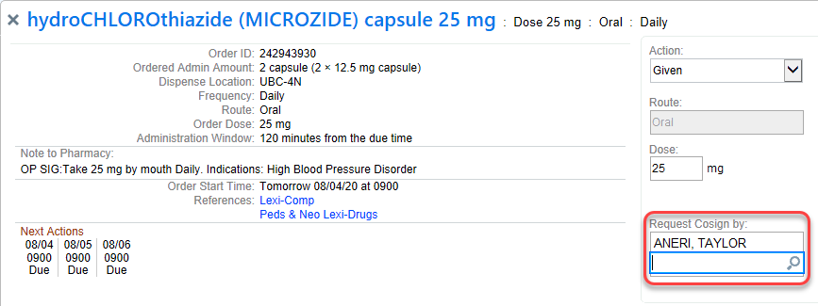
NOTE: Students cannot administer medications that require a double check. This requires two licensed professionals to document the administration.

Writing Notes (Allied Health Only)
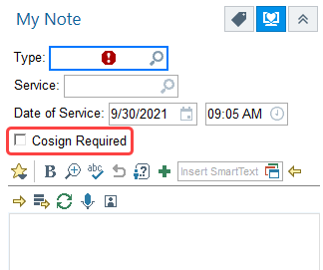
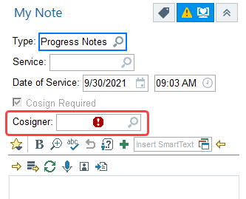
When writing a Note, the student is responsible for adding a cosigner to the note or checking the Cosign Required box within the note.

Staff:

Cosign from Reports
NOTE: All Students that have documented on the patient will be listed in this report. Verify that you are only cosigning for the student that you are supervising on the correct date.

All documentation can be easily reviewed and cosigned using the Cosign report. This report may be a default report or can be searched for in the Patient List screen.

- In Patient Lists, use the Patient List Reports search bar and search for the Cosign Report (Nursing and Respiratory) or Needs Cosign (Allied Health)
- The Cosign Report will appear in the bottom portion of the Patient List screen for the patient selected
- Within this report the licensed clinician can cosign documentation in multiple ways as shown below.

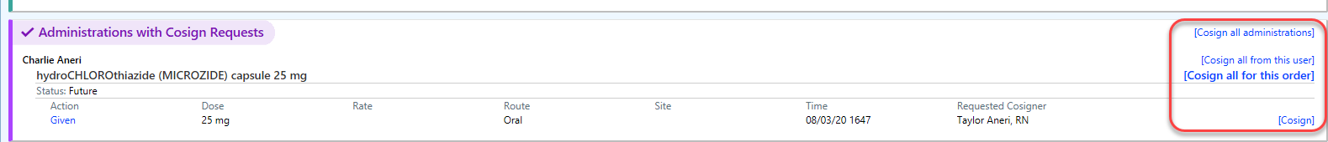
Medications (Nursing and Respiratory Only)
Notes (Allied Health Only)
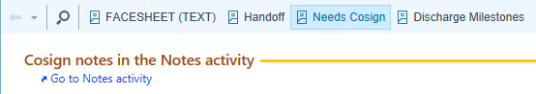

Cosign from Flowsheets
Flowsheet documentation may be cosigned from within the Flowsheet activity in multiple ways.
- Using the Cosign button
- Review the documentation and complete cosign by choosing Cosign All or Cosign individual rows
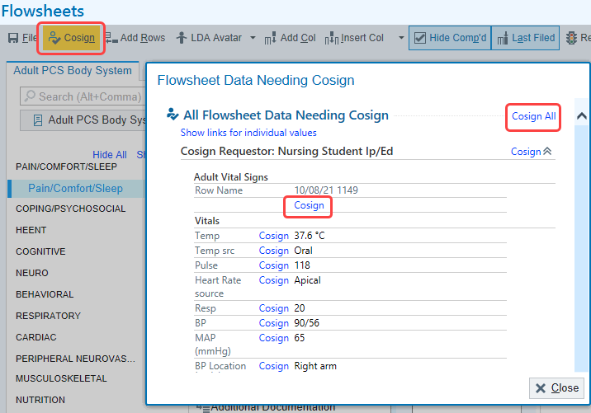

Cosign from Notes (Allied Health Only)
Note and Care Plan note documentation needs to be cosigned.
- Go to the Notes Activity.
- Select the note you need to cosign
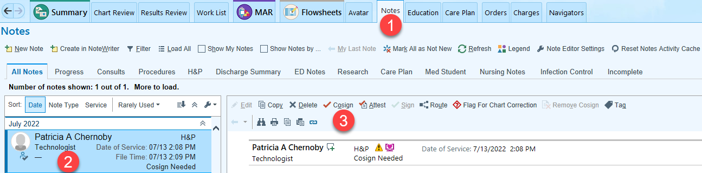
- Click Cosign.
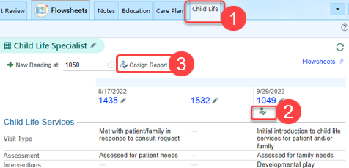

Cosign from Navigators (Allied Health Only)
- Click on the Child Life navigator
- The Cosign Required symbol appears where you need to Cosign
- Click the Cosign Report to complete the cosign after reviewing the student documentation

Add a Patient List Column
A Patient List column can be added that will give a visual indicator when that patient has documentation that needs to be cosigned.
- Under Patient Lists tab, click Properties.
- While on the General tab, type in the search box for My Cosign.
- Click on the Flowsheet Requires my Cosign.
- Click Add Column.
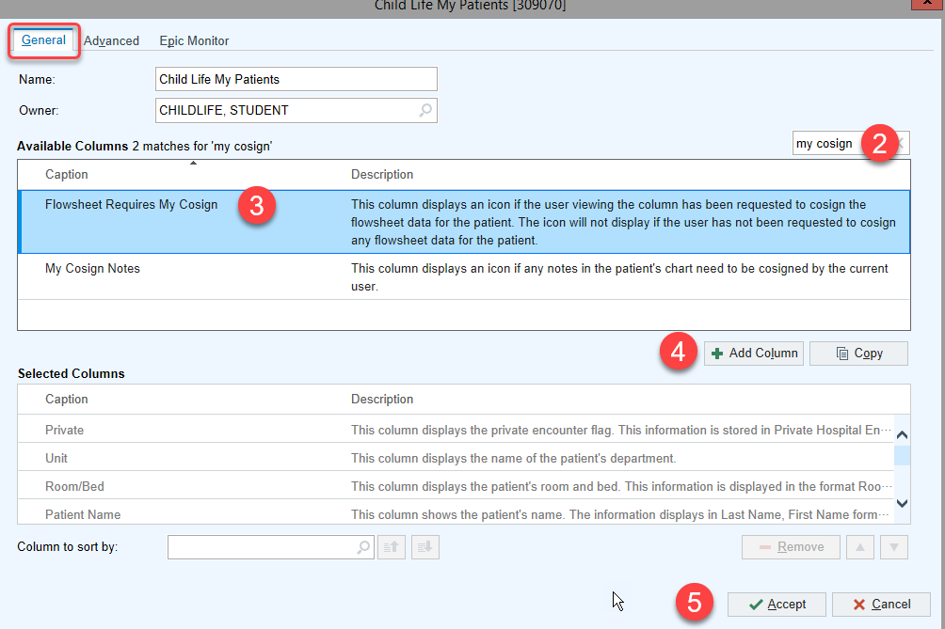
- Click Accept.
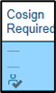
Now when a student documents on patient that is within your Patient list, a Cosign icon will now appear in your “Flowsheet Requires my Cosign” column on your patient list.

